**Software Requirements Specifications (SRS)**

**ERP Solution for Lakhsma Sweater Ltd.**

REFERENCE: GW/ERP/SRS/Inventory

**Version: 1.0**

**Date of Release: October 14, 2015**



**Genweb2 Limited**

TK Bhaban (11th Floor),

13 Kazi Nazrul Islam Avenue,

Kawran Bazar, Dhaka 1215, Bangladesh

web: [http://www.genweb2.com](http://www.genweb2.com/)

**Contents**

Document Release History 5

1.0 Introduction 6

1.1 Purpose of SRS 6

2.0 Procurement 7

2.1 Overview 7

2.2 Functional features of inventory modules are given below 7

2.3 Inventory Process flow 7

2.4 User Class 8

3.0 Process Flow: 10

3.1 Raise Indent Process 10

3.2 Receive Goods Process 11

3.3 Receive Return Process 12

3.4 QC Process 13

3.5 Inventory Item Transfer Process 14

3.6 Item Allocation, DE allocation and Reallocation Process 16

3.7 Issue Item Process 18

3.8 Issue Return Process 19

3.9 Physical Inventory Process 20

3.10 Item Adjustment Process 21

4.0 USE CASE Diagram 23

4.1 Raise Indent Process 23

4.2 Receive Goods: 23

4.3 Receive Return Process: 24

4.4 QC Process 24

4.5 Inventory Item Transfer Process 25

4.6 Item Allocation, De-allocation and Reallocation Process 26

4.7 Item Issue process 26

4.8 Issue Return Process 27

4.9 Physical Inventory Process 27

4.10 Item Adjustment Process 27

5.0 USE CASE Details 28

5.1 UC/INV/001/ Raise Indent 28

5.2 UC/INV/002/ Edit/Modify Indent 29

5.3 UC/INV/003/ Approve Indent 30

5.4 UC/INV/004/ Cancel Indent 31

5.5 UC/INV/005/ Close Indent 32

5.6 UC/INV/006/ Receive Goods against Purchase Order 35

5.7 UC/INV/007/ Receive Return to Supplier before QC 35

5.8 UC/INV/008/ Purchase Order Cancellation for Received Return Items 36

5.9 UC/INV/009/Perform QC of receive goods 37

5.10 UC/INV/010/Receive Return to Supplier after QC 38

5.11 UC/INV/011/ Update stock with QC passed quantity 39

5.12 UC/INV/012/ Return QC Failed Quantity to Supplier 40

5.13 UC/INV/013/ Order Cancellation for QC failed items/Qty 41

5.14 UC/INV/014/ Receive replaced goods of QC failed returned qty 41

5.15 UC/INV/015/ Request for Item Transfer 42

5.16 UC/INV/016/ Approve Transfer Request 43

5.17 UC/INV/017/ Cancel Transfer Request 44

5.18 UC/INV/018/ Transfer out goods from one location by transfer note 45

5.19 UC/INV/019/ Transfer In goods against Transfer Note 46

5.20 UC/INV/020/In transit Item adjustment 46

5.21 UC/INV/021/ Request for item allocation 47

5.22 UC/INV/022/ Approve Allocation Request 49

5.23 UC/INV/023/ Cancel Allocation Request 49

5.24 UC/INV/024/ Allocate Goods from Bulk Stock to EPO 50

5.25 UC/INV/025/ De Allocate Goods from EPO to Bulk 51

5.26 UC/INV/026/ re Allocate Goods from EPO to EPO 52

5.27 UC/INV/027/ Issue Stock against Indent (from Production floor) 53

5.28 UC/INV/028/ Issue Stock against Indent (From Employee) 53

5.29 UC/INV/029/ Receive Issued Item 54

5.30 UC/INV/030/ Return Issued Item 55

5.31 UC/INV/031/ Physical Inventory 56

5.32 UC/INV/032/ Adjust Item 57

5.33 UC/INV/033/ Adjust Item(s) for item missing 58

5.34 UC/INV/034/Adjust Item(s) for Item damage 59

6.0 Inventory Mock-up 60

6.1 Product Creation 60

6.2 Indent 61

6.3 Inventory Receive 62

6.4 Receive Return 63

6.5 Inventory QC 64

6.6 Inventory Transfer Out 65

6.7 Inventory Transfer In 66

6.8 Inventory Item allocation &De-allocation 67

6.9 Inventory Issue 68

6.10 Physical Inventory 69

6.11 Item Adjustment 70

Document Release History

| Sl. No. | Version Number | Release Date | Prepared By | Reviewed By | Approved By | Reasons for New Release |
| --- | --- | --- | --- | --- | --- | --- |
| 1 | 1.0 | 14th Oct, 2015 | Nazifa Chowdhury |  | N/A | 1st Release |
|  |  |  |  |  |  |  |

# Introduction

## Purpose of SRS

The purposes of this SRS are to clearly identify the customer requirements and provide a detailed document. The customer will review the document and approve/make change as required. It will also help the review team to be able to validate whether the customer requirements has been fulfilled.

The SRS will also help the Analyst and Designer to understand and track the Requirements for the proposed system. It will also identify a set of requirements for the Development of the project. The SRS helps to describe the behavior of the system to be developed.

# Procurement

## Overview

Inventory management is a science primarily about specifying the shape and percentage of stocked goods. It is required at different locations within a facility or within many locations of a supply network to precede the regular and planned course of production and stock of materials.

## Functional features of inventory modules are given below

* Floor Manager or Employee/ Department raises indent
* Approval Authority verifies the Indent with necessary information
* Store Keeper sends all products according to Indent information to Floor Manager or Employer or Department
* Store Keeper receives goods according to Purchase Order
* QC Authority checks quality and quantity of goods according to Purchase Order
* If goods are in good quality and exact quantity then QC accept goods and update the stock of the goods
* If goods are not in good condition and not exact quantity, QC Authority returns the rejected goods
* Store Keeper sends back all rejected goods to Supplier
* Store Keeper checks all goods and if finds any mismatch then sends the goods to Supplier
* Transfer Request Authority (Merchandiser / Storekeeper / others) sends request to Approval Authority for item transfer
* Storekeeper receives request from approval authority for transfer out item from stock
* Based on approval storekeeper can transfer item from one stock to another stock
* Items can be allocated or de-allocated or re-allocated between EPO to Bulk and vice versa
* Storekeeper can issue item to Floor Manager or Employee / Department against indent
* Floor Manager or Employee / Department can return issued item
* Storekeeper can adjust the difference item stock in between system and physical
* Item can be adjusted in case of missing or damaged

## Inventory Process flow

* Raise indent process
* Receive goods process
* Receive return process
* QC process
* Inventory item transfer process
* Item allocation, de-allocation and reallocation process
* Issue item process
* Issue return process
* Physical inventory process
* Item adjustment process

## User Class

|  |  |  |
| --- | --- | --- |
| User Class/ Actor | Characteristics | Responsibilities |
| Floor Manager/Employee | * Raise Indent * Receive Issued Item * Return Issued Item | * Add, modify documents * Maintain other documents related information |
| Approval Authority | * Approve Indent | * Add, modify documents * Approve document * Add necessary comments during approval if required |
| Authority | * Cancel Indent * Close Indent | * Add, modify documents * Approve document * Provide necessary comments during approval if required |
| Storekeeper | * Receive goods against Purchase Order * Receive Return to Supplier before QC * Receive Return to Supplier after QC * Return QC failed quantity to Supplier * Receive replaced goods of QC failed returned qty * Transfer out goods from one location by transfer note * Transfer In goods against Transfer Note * In transit Item adjustment * Allocate goods from Bulk stock to EPO * De allocate goods from EPO to Bulk * Re allocate goods from EPO to EPO * Issue Stock against Indent (from Production floor) * Issue Stock against Indent (From Employee) * Physical Inventory Adjust | * Add, modify documents * Maintain other documents related information |
| Procurement/Authority | * Purchase Order Cancellation for Returned Items * Order Cancellation for QC failed items/Quantity | * Order Cancellation for QC failed items/Qty |
| QC | * Perform QC of received goods | * QC assure the item quality validation |
| System | * Update stock with QC passed quantity | * Add/modify item * System update |
| Merchandiser, Employee, Storekeeper | * Request for item transfer * Cancel Transfer Request * Request for item allocation * Cancel Allocation Request | * Add/modify item * Provide necessary comments during approval if required |
| Receive Authority | * Receive Issued Item * Return Issued Item | * Add, modify documents * Approve document * Provide necessary comments during approval if required |

# Process Flow:

## Raise Indent Process

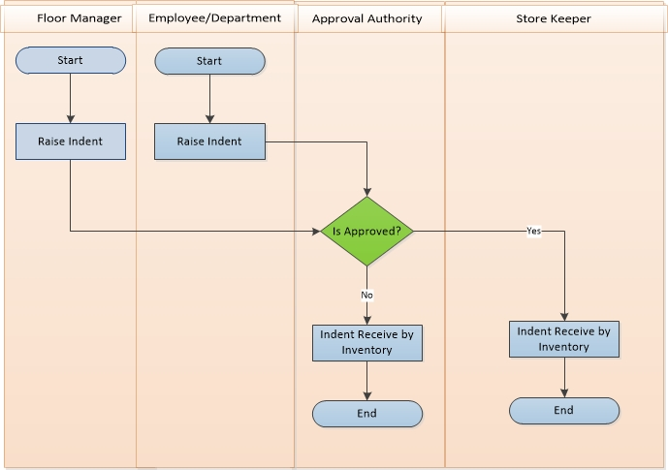

**Raise Indent Process Description:**

* Floor Manager or Employee/ Department raise Indent when they need products for production.
* They send the Indent to Approval Authority to approve the Indent.
* Approval Authority verifies the Indent with necessary information. Depending on approval decision further process –
  + Approved: If approved, then Approval Authority sends the approval message to store keeper to take necessary steps.
  + Not Approved: If not approved, then Approval Authority cancels the Indent and stops the Raise Indent Process in the point.
* According to approval message, Store Keeper accepts Indent information with confirmation message.
* Store Keeper sends all products according to Indent information to Floor Manager or Employer or Department.

## Receive Goods Process

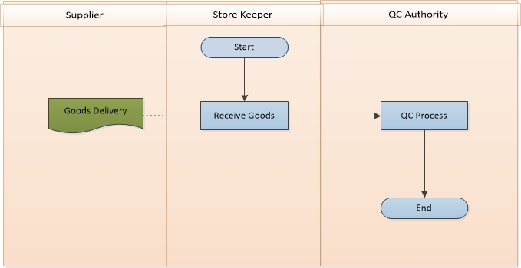

**Receive Goods Process Description**

* Supplier sends goods with Purchase Order to Store Keeper.
* Store Keeper receives goods and Purchase Order. Store Keeper inserts all necessary information into system which was taken from Purchase Order.
* Store Keeper confirms his acceptance and sends all goods to QC Authority for proper quality control.
* QC Authority receives all goods and ends the process.

## Receive Return Process

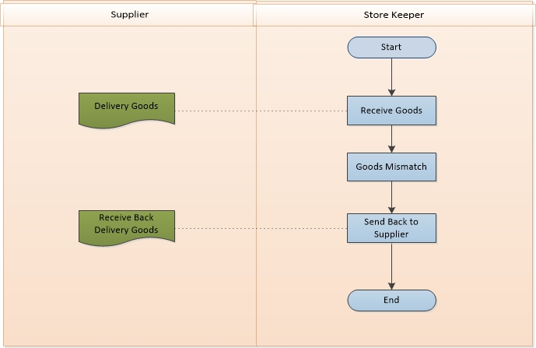

**Receive Return Process Description**

* Supplier sends goods with Purchase Order to Store Keeper.
* Store Keeper receives goods and Purchase Order.
* Store Keeper checks all goods and if finds any mismatch then sends the goods to Supplier.
* If received goods match then, Store Keeper inserts all necessary information into system which was taken from Purchase Order.

## QC Process

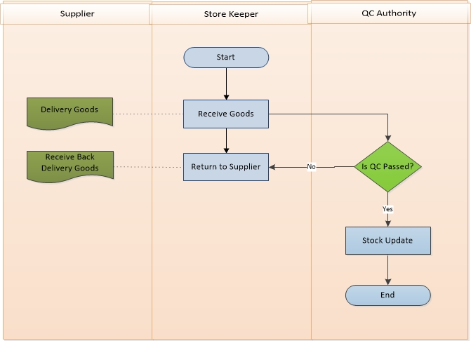

**QC Process Description**

* Supplier sends goods with Purchase Order to Store Keeper.
* Store Keeper receives goods and sends goods to QC Authority.
* QC Authority receives all goods.
* QC Authority checks quality and quantity of goods according to Purchase Order. According to QC result they take necessary decision-
  + QC Passed:
    - If goods are in good quality and exact quantity then QC accept goods and update the stock of the goods.
  + QC Failed:
    - If goods are not in good condition and not exact quantity, QC Authority returns the rejected goods to Store Keeper.
* Store Keeper receives all rejected goods send by QC Authority. Store Keeper back all rejected goods to Supplier.

## Inventory Item Transfer Process

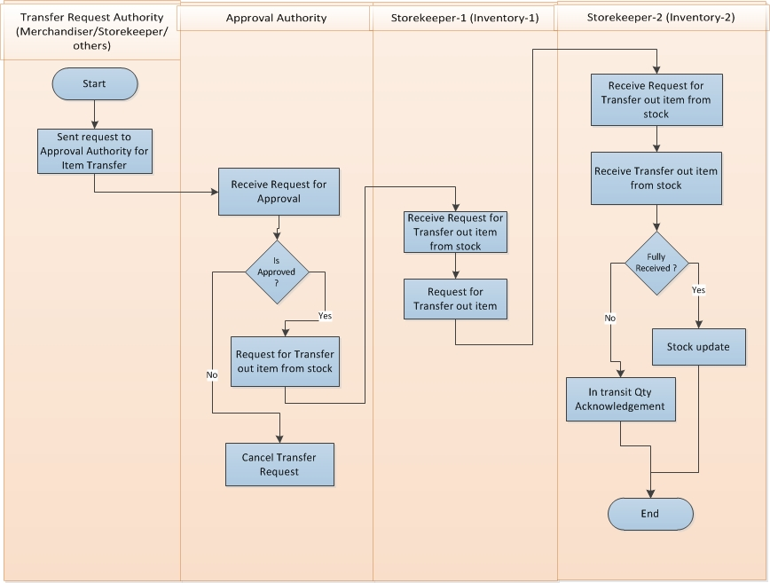

**Inventory Item Transfer Process Description**

* Transfer Request Authority (Merchandiser / Storekeeper / others) sends request to Approval Authority for item transfer.
* Approval Authority receives request for approval from Transfer Request Authority.
* If Approval Authority is not approved then cancel the transfer request.
* If Approval Authority is approved then request to storekeeper-1 (inventory-1) for transfer out item from stock.
* Storekeeper-1 (inventory-1) receive request from approval authority for transfer out item from stock.
* Storekeeper-1 (inventory-1) request to Storekeeper-2 (inventory-2) for transfer out item from stock.
* Storekeeper-2 (inventory-2) receive request from Storekeeper-1 (inventory-1) for transfer out item from stock.
* If Storekeeper-2 (inventory-2) full item receive then stock update.
* If Storekeeper-2 (inventory-2) full item not receive then in transit quantity acknowledge

## Item Allocation, DE allocation and Reallocation Process

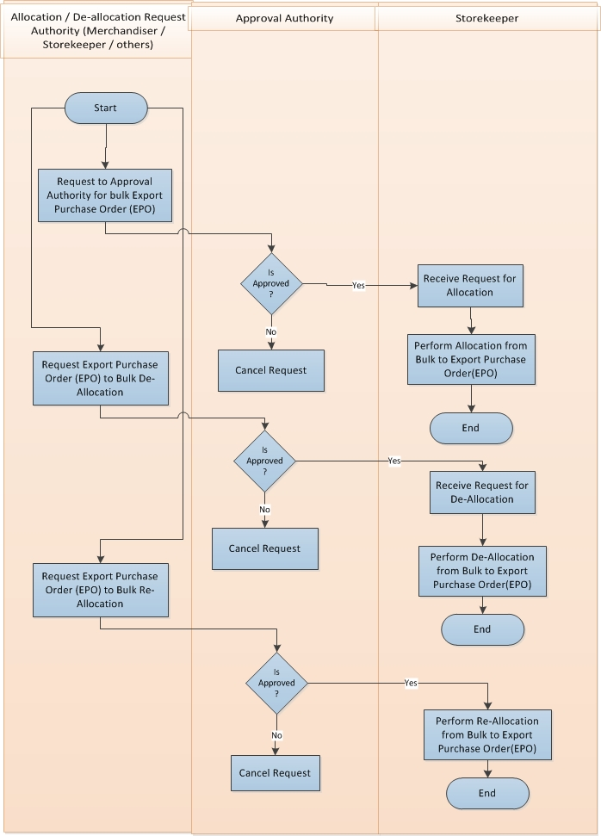

**Item Allocation, DE allocation and Reallocation Process Description**

* Allocation / De-allocation / Re-allocation request authority (Merchandiser / Storekeeper / Others) request to approval authority for bulk export purchase order (EPO) .
* Approval Authority receives request for approval for bulk export purchase order (EPO)
* If Approval Authority is not approved then request is cancel.
* If Approval authority is approved then request to storekeeper for allocation
* Storekeeper receive request for allocation
* Storekeeper execute allocation from bulk to export purchase order (EPO)
* Allocation / De-allocation / Reallocation request authority (Merchandiser / Storekeeper / Others) request to approval authority for export purchase order (EPO) to bulk de-allocation
* Approval authority receive request for approval for export purchase order (EPO) to bulk de-allocation.
* If Approval authority is not approved then request is cancel
* If Approval authority is approved then request to storekeeper for de-allocation
* Storekeeper receive request for de-allocation
* Storekeeper execute de-allocation from bulk to export purchase order (EPO)
* Allocation / De-allocation / Reallocation request authority (Merchandiser / Storekeeper / Others) request to approval authority for export purchase order (EPO) to bulk re-allocation
* Approval authority receive request for approval for export purchase order (EPO) to bulk re-allocation.
* If Approval authority is not approved then request is cancel
* If Approval authority is approved then request to storekeeper for re-allocation
* Storekeeper receive request for re-allocation
* Storekeeper execute re-allocation from bulk to export purchase order (EPO)

## Issue Item Process

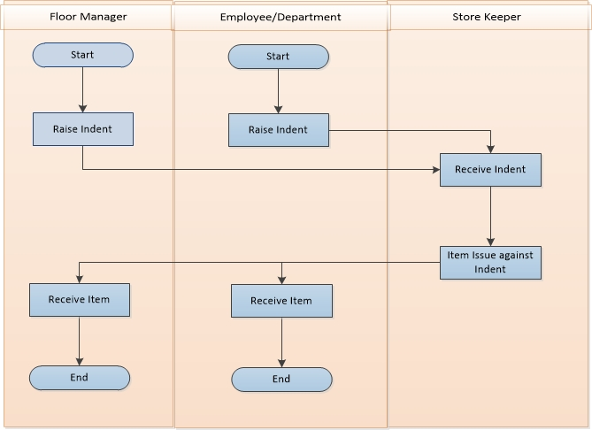

**Issue Item Process Description**

* Floor Manager or Employee / Department raise indent
* Storekeeper receive indent from Floor Manager or Employee / Department
* Storekeeper issue item to Floor Manager or Employee / Department against indent
* Floor Manager or Employee / Department receive issued item

## Issue Return Process

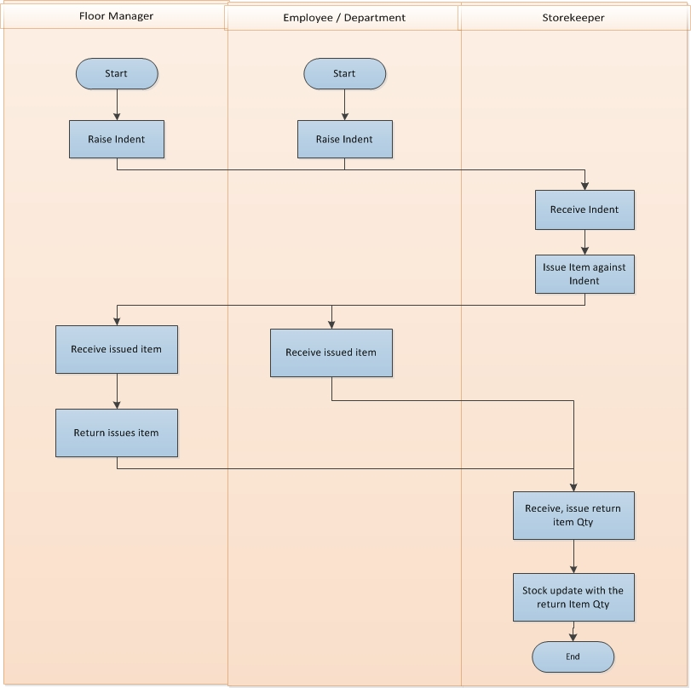

**Issue Return Process Description**

* Floor Manager or Employee / Department raise indent
* Storekeeper receive indent from Floor Manager or Employee / Department
* Storekeeper issue item to Floor Manager or Employee / Department against indent
* Floor Manager or Employee / Department receive issued item
* Floor Manager or Employee / Department can return issued item if not use all item
* Storekeeper receive return item from Floor Manager or Employee / Department
* Storekeeper update stock with the return item

## Physical Inventory Process

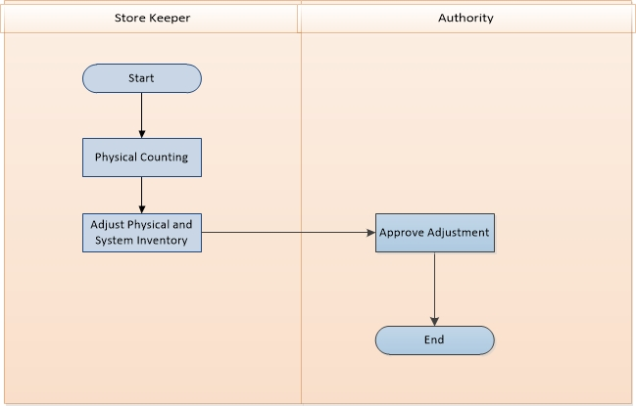

**Physical Inventory Process Description**

* Storekeeper will count item stock physically
* Storekeeper adjust the difference item stock in between system and practical
* Authority approve the item adjustment

## Item Adjustment Process

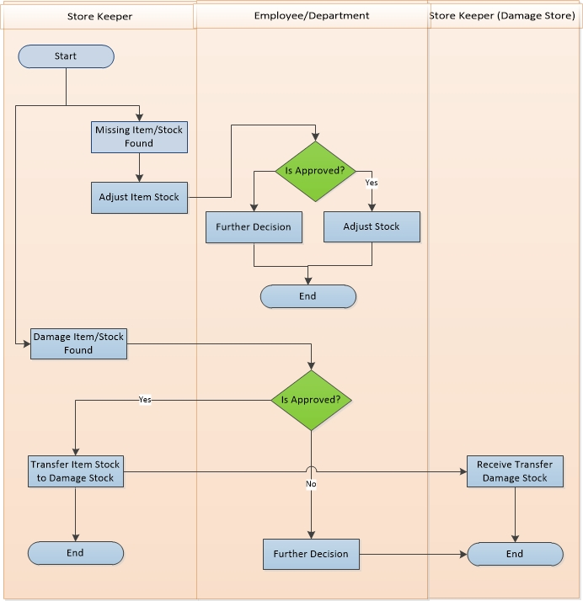

**Item Adjustment Process Description**

* Store Keeper adjusts item/stock depending on various conditions.
  + Missing item/stock:
    - If Store Keeper found any missing item/stock, Store Keeper sends adjustment request to Authority.
    - Authority takes decision depending on some condition. If approved the request then stock will adjust otherwise they take further decision.
  + Damage item/stock:
    - If Store Keeper found any damage item/stock, Store Keeper sends damage item transfer out request to Authority.
    - Authority takes decision depending on some condition. If approved the request then accept the request and response accepted message to Store Keeper.
    - Store Keeper sends damage item to Store Keeper (Damage Store) damage items stock.
    - If cancel the request then Authority takes further decision.

# USE CASE Diagram

## Raise Indent Process

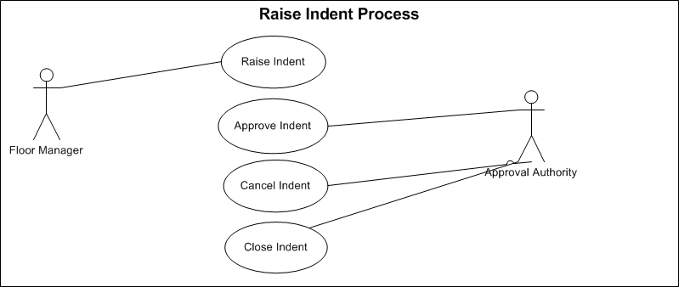

Fig: Raise indent

## Receive Goods:

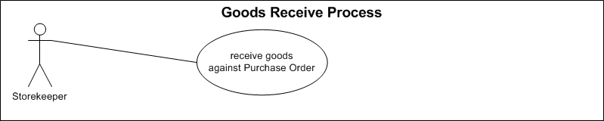

Fig: Good receive process

## Receive Return Process:

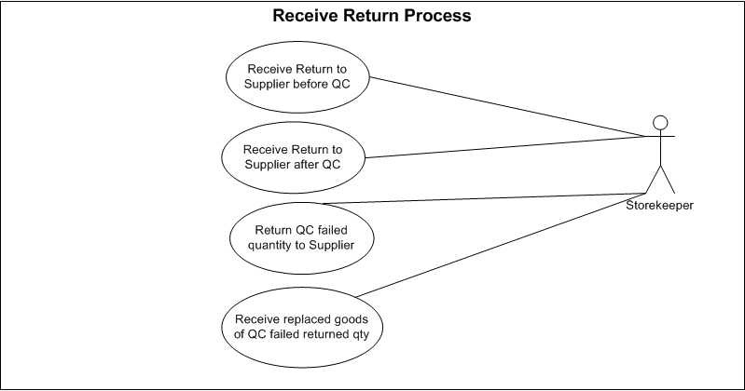

Fig: Receive return process

## QC Process

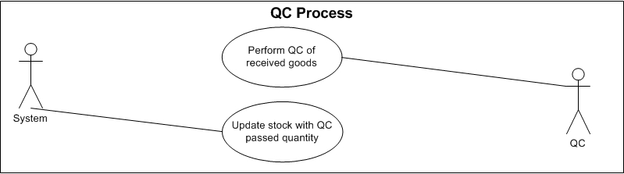

Fig: QC process

## Inventory Item Transfer Process

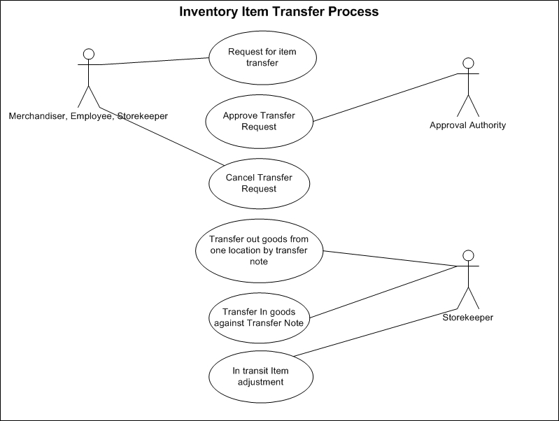

Fig: Inventory item transfer process

## Item Allocation, De-allocation and Reallocation Process

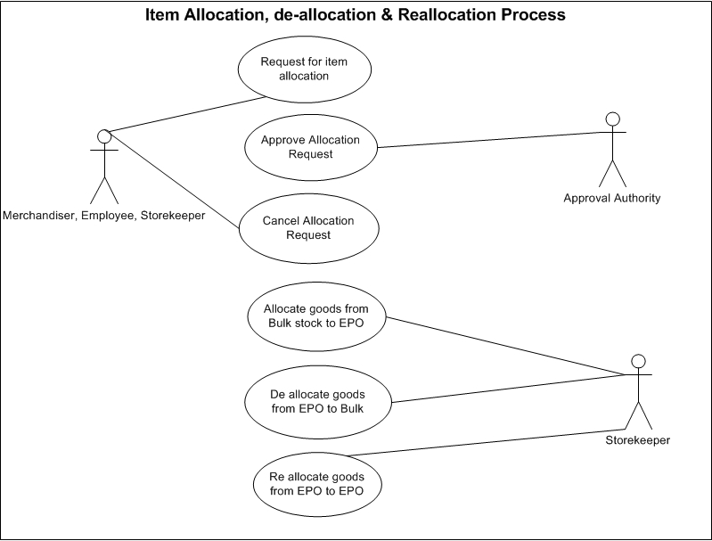

Fig: Item allocation, de-allocation and reallocation process

## Item Issue process

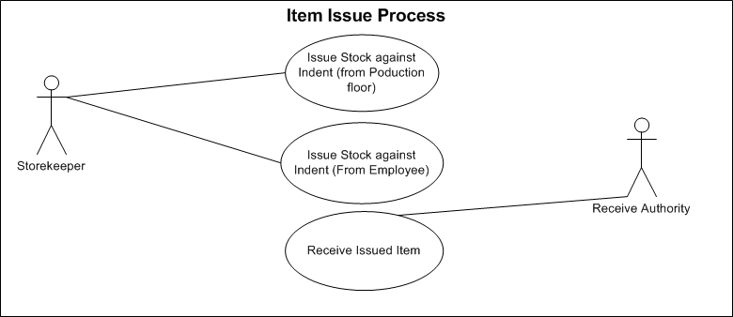

Fig: Item issue process

## Issue Return Process

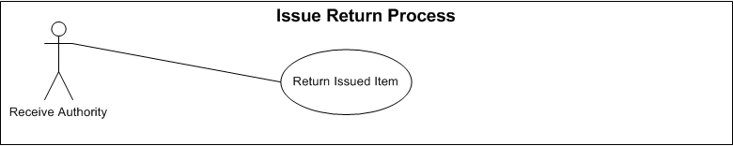

Fig: Issue return process

## Physical Inventory Process

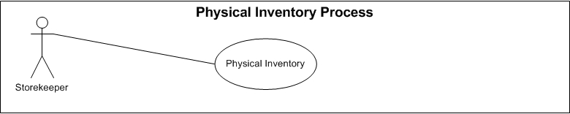

Fig: Physical Inventory Process

## Item Adjustment Process

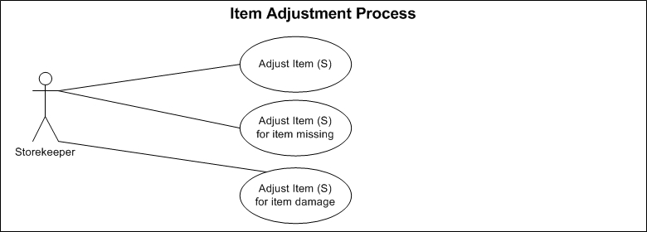

Fig: Item adjustment process

# USE CASE Details

## UC/INV/001/ Raise Indent

|  |  |
| --- | --- |
| Use Case ID: UC/INV/001 | |
| Use Case Name**: Raise Indent** | |
| Created By: **GenWeb2 Ltd.** | Date Created: 13 October, 2015 |
| Actors: | * Floor Manager/Employee |
| Trigger: | * When Production floor needs any raw materials * When any Employee or Department need any consumable items |
| Business Rule | * Indent can be raised by Production floor for raw materials requires for Finished Goods production * Indent can be raised by any Employee or any department whenever any consumable items require * Multiple item can exist in single Indent. * Indent will have the target store name * Only approved Indent(s) will be available to Inventory authority for further action |
| Description: | Whenever any item is require for production or general consumption then the related authority ask the require item(s) from Inventory authority through Indent. One Indent is for raw materials and another one id for general consumption |
| Frequency of Use | * Medium |
| Preconditions | * Item (s) must be exists in System. * Unit of Measurement must exists in System. |
| Post Conditions | * Appropriate message will be displayed after each entry being saved / updated. * Approval Authority will be notified for approval response. |
| Assumption | * N/A |
| Goal | Create Indent in system |
| Normal Flow | * Indent raise by the authority for any raw materials/consumable goods requirement * Approval authority approve the Indent * Inventory authority receive the Indent for further action |
| Alternate Flow | N/A |
| Exception | * Proper message should be displayed if Indent can’t be saved. * Proper message should be displayed if any master or dependent data is missing or not found. * Appropriate message should be displayed if mandatory fields are not filled. * Any system exception/Application exception should be handled centrally with proper user message during the page browse/save/update/view operations. |
| Cross Reference | * N/A |

## UC/INV/002/ Edit/Modify Indent

|  |  |
| --- | --- |
| Use Case ID: UC/INV/002 | |
| Use Case Name**: Edit/Modify Indent** | |
| Created By: **GenWeb2 Ltd.** | Date Created: 13 October, 2015 |
| Actors: | * Inventory Authority |
| Trigger: | * When any modification requires for any unapproved Indent. |
| Business Rule | * If Indent is not approved then Edit/Modification can take place. * Modification after approval needs special permission. * Modification can take place if there is any mistake in Indent. * Modification can take place if there is any changes in Indent. |
| Description: | If changes or modification requires for any raised and unapproved Indent then concern authority edit/modify that Indent. |
| Frequency of Use | Medium |
| Preconditions | * Indent must exist in System. * Indent status must be “active”. * Indent must be at unapproved state. |
| Post Conditions | * Appropriate message will be displayed after each entry being saved/updated. * Approval Authority will be notified for approval response. |
| Assumption | * N/A |
| Goal | Adjust necessary changes in Indent |
| Normal Flow | * Authorized user can edit/modify unapproved Indent. * Authorized user can login to system and open the Indent needs to modify. * User can edit/modify require Item (s) & Quantity. |
| Alternate Flow | * Approved Indent get special permission to modify by the Authorized user. * Authorized user edit/modify respective modification requirements. |
| Exception | * Proper message should be displayed if no content is found while loading the project list. * Appropriate message should be displayed if mandatory fields are not filled. * Any system exception/application exception should be handled centrally with proper user message during the page browse/save/update/view operations. |
| Cross Reference | * Use Case ID: UC/INV/001 |

## UC/INV/003/ Approve Indent

|  |  |
| --- | --- |
| Use Case ID: UC/INV/003 | |
| Use Case Name**: Approve Indent** | |
| Created By: **GenWeb2 Ltd.** | Date Created: 13 October, 2015 |
| Actors: | * Approval Authority |
| Trigger: | * When any raised Indent needs approval for further action |
| Business Role | * Approval Authority get notification for pending approval of Indent (s) * Approval authority approve the Indent to enable it for further business action * Approval authority reject the Indent to prevent it for any further business action |
| Description: | After raising Indent by the Production Floor Manager/Employee it needs to be approved by the approval authority for further approval |
| Frequency of Use | * Medium |
| Preconditions | * Indent must exists in System. * Approval Authority got notification for pending approval. |
| Post Conditions | * Indent will be approved. * Approved Indent will be freeze for any further modification. * Approved Indent will be available to Inventory for further action. |
| Assumption | * N/A |
| Goal | Approve Indent for further use. |
| Normal Flow | * Production Floor authority raise Indent for Production raw materials. * Employee/Department raise indent for general consumable item(s) * Approval Authority get notification for pending approval. * Approval Authority Approve the Indent. * Approved Indent can’t be modified. |
| Alternate Flow | * Production Floor authority raise Indent for Production raw materials. * Employee/Department raise indent for general consumable item(s) * Defined approval authority other than Floor Manager/ Department Head can approve the Purchase Requisition. |
| Exception | * Proper message should be displayed if no content is found while loading the Indent. * Appropriate message should be displayed if approval not possible. * Any system exception/application exception should be handled centrally with proper user message during the page browse/save/update/view operations. |
| Cross Reference | * Use Case ID: UC/INV/001 |

## UC/INV/004/ Cancel Indent

|  |  |
| --- | --- |
| Use Case ID: UC/INV/004 | |
| Use Case Name**: Cancel Indent** | |
| Created By: **GenWeb2 Ltd.** | Date Created: 13 October, 2015 |
| Actors: | * Production Floor Authority, Employee |
| Trigger: | When any raised Indent canceled by the indenter |
| Business Role | * Authorized user created Indent * Indent may or may not be approved * Indent is not require any more so it needs to be cancelled. * Indent Can’t be cancelled if indenter has already received item(s) against the Indent |
| Description: | If any Indent get Invalid then the authority cancel that Indent |
| Frequency of Use | * Low |
| Preconditions | * Indent must exists. * No Inventory issue happen against the Indent * No Purchase Requisition has created against the Indent. * Entire Indent quantity is pending yet to create Purchase Requisition. * Only Authorized authority can cancel Indent. |
| Post Conditions | * Indent will be cancelled. * No further business action will take place after cancellation of Indent. * Indent will not be available to Issue Inventory Item against it. * Indent will not be available to create Purchase Requisition. * If Purchase Requisition was created against any Indent then the related user will be notified to cancel the Purchase Requisition. |
| Assumption | * N/A |
| Goal | Cancel any Indent |
| Normal Flow | * Production floor Authority raise Indent for production raw materials items. * Employee or Department raise Indent for General consumable items * Authorized user Cancel the Indent (Approved & unapproved both). |
| Alternate Flow | * N/A |
| Exception | * Proper message should be displayed if no content is found while loading the Indent. * Appropriate message should be displayed if Cancellation not possible. * Any system exception/application exception should be handled centrally with proper user message during the page browse/save/update/view operations. |
| Cross Reference | * Use Case ID: UC/INV/001 |

## UC/INV/005/ Close Indent

|  |  |
| --- | --- |
| Use Case ID: UC/INV/005 | |
| Use Case Name**: Close Indent** | |
| Created By: **GenWeb2 Ltd.** | Date Created: 13 October, 2015 |
| Actors: | * Production Floor Authority, Employee or Authorized User |
| Trigger: | When any raised Indent need to be closed before completing the full operation. |
| Business Role | * Production floor Authority raise Indent for production raw materials items. * Employee or Department raise Indent for General consumable items * Indent is already approved. * Indent cannot be cancelled. * Purchase Requisition has already been generated against the Indent (Partially). * No Purchase Requisition will be created against the Indent for pending Items(Ex: Indent is having 1000 quantity and Purchase Requisition was created for 400 quantity and somehow it has been decided that no Purchase Requisition will be generated for the balance 600 qty. In that case Indent can’t be cancelled as already valid Purchase Requisition exists against it, On the other side it can’t display 600 quantity as balance for yet to create Purchase Requisition so Close statement of any Indent will keep the Existing Purchase Requisition active and no Indent quantity will be displayed as pending). * Or Inventory issue has already been triggered against the Indent (Partially) * No Purchase Requisition will be created against the Indent for pending Items(Ex: Indent is having 1000 quantity and Purchase Requisition was created for 400 quantity and somehow it has been decided that no Purchase Requisition will be generated for the balance 600 qty. In that case Indent can’t be cancelled as already valid Purchase Requisition exists against it, On the other side it can’t display 600 quantity as balance for yet to create Purchase Requisition so Close statement of any Indent will keep the Existing Purchase Requisition active and no Indent quantity will be displayed as pending). * No Inventory issue will happen against the Indent for pending Items(Ex: Indent is having 1000 quantity and Inventory has issued 400 quantity and somehow it has been decided that no Inventory issue will happen for the balance 600 quantity as it is not require for the Indenter anymore. In that case Indent can’t be cancelled as already Inventory issue has taken place, On the other side it can’t display 600 quantity as balance for yet to Issue from Inventory so Close statement of any Indent will keep the Existing Inventory issue active and no Indent quantity will be displayed as pending). |
| Description: | If any Indent have some pending Quantity to issue from Inventory or create Purchase Requisition but decision has taken that it will not be executed anymore or not require in that case the Indent will be declared as ‘Closed’ so that it will not display the pending item Indent quantity for Inventory issue or Create Purchase Order anymore. |
| Frequency of Use | * Low |
| Preconditions | * Indent must exists. * Indent may get approved. * Inventory item (s) has been issued partially against the Indent. * Purchase Requisition has created against the Indent for partial quantity. * Pending Indent quantity must exists to issue from Inventory for create Purchase Requisition. |
| Post Conditions | * Indent will be state as closed. * Already Issued item (s) from Inventory against the Indent will remain same. * Already created Purchase Requisition will remain same. * Item can’t be issue anymore against the Indent. * New Purchase Requisition can’t be created against that Indent. |
| Assumption | * N/A |
| Goal | Close any Indent. |
| Normal Flow | * Production floor Authority raise Indent for production raw materials items. * Employee or Department raise Indent for General consumable items. * Floor Manager/Authority approve the Indent. * Inventory authority issue item(s) against the indent (Partially). * Inventory Authority Create Purchase Requisition (Partial). * Authority got decided that inventory issue will not happen newly against the pending quantity of the Indent. * Authority got decided that no further Purchase Requisition will be created against the pending quantity of the Indent. * Close Purchase Requisition. * Indent will not be available to issue Inventory item(s) for pending quantity. * Indent will not be available for create Purchase Requisition for pending quantity. |
| Alternate Flow | * N/A |
| Exception | * Proper message should be displayed if no content is found while loading the Indent. * Appropriate message should be displayed if Indent Closing not possible. * Any system exception/Application exception should be handled centrally with proper user message during the page browse/save/update/view operations. |
| Cross Reference | * Use Case ID: UC/INV/001 |

## UC/INV/006/ Receive Goods against Purchase Order

|  |  |
| --- | --- |
| Use Case ID: UC/INV/006 | |
| Use Case Name**: Receive Goods against Purchase Order** | |
| Created By: **GenWeb2 Ltd.** | Date Created: 13 October, 2015 |
| Actors: | * Storekeeper |
| Trigger: | * When Inventory authority receives goods against Purchase order |
| Business Role | * Supplier deliver goods to Inventory against the given Purchase Order * Inventory Authority receive the goods against Purchase Order |
| Description: | * Supplier deliver goods to Inventory as per the given Purchase Order, Storekeeper receive delivered goods as per the documents. |
| Frequency of Use | * Medium |
| Preconditions | * Approved Purchase Order issued to Supplier. * Inventory Location must exist. |
| Post Conditions | * Item(s) will be received against the Supplier Purchase Order. * It will move to QC Process * QC authority will receive notification for pending QC |
| Assumption | * N/A |
| Goal | Receive Delivered Items from Supplier against the Purchase Order |
| Normal Flow | * Procurement authority issue Purchase Order to Supplier against Bill of Materials (BOM) * Procurement authority issue Purchase Order to Supplier against Purchase Requisition. * Supplier deliver goods to Inventory against the Purchase Order * Inventory Authority receives goods from supplier against the Purchase Order. |
| Alternate Flow | * N/A |
| Exception | * Proper message should be displayed if Inventory receive transaction cannot be saved. * Proper message should be displayed if any master or dependent data is missing or not found. * Appropriate message should be displayed if mandatory fields are not filled. * Any system exception/Application exception should be handled centrally with proper user message during the page browse/save/update/view operations. |
| Cross Reference | * Use Case ID: UC/PRO/010 |

## UC/INV/007/ Receive Return to Supplier before QC

|  |  |
| --- | --- |
| Use Case ID: UC/INV/007 | |
| Use Case Name**:** Receive Return to Supplier before QC | |
| Created By: **GenWeb2 Ltd.** | Date Created: 13 October, 2015 |
| Actors: | * Storekeeper |
| Trigger: | * When inventory received items needs to return to supplier. |
| Business Rule | * Supplier deliver goods to Inventory against the given Purchase Order * Inventory Authority receive the goods against Purchase Order * Inventory authority return the goods to supplier for any reason * Inventory received goods will not move to QC process or will not be added to Inventory stock |
| Description: | Supplier delivered goods to storekeeper as per the Purchase Order Storekeeper receives goods accordingly but If there is any mismatch then storekeeper return the goods to supplier |
| Frequency of Use | * Low |
| Preconditions | * Supplier Purchase Order Must exist * Inventory receive must exist against the Purchase Order |
| Post Conditions | * Appropriate message will be displayed after successfully returning the received items in system. * Received item quantity will not flow to QC process. * Received item quantity will be added in pending Purchase Order delivery quantity * This quantity will be available to receive again from Supplier |
| Assumption | * N/A |
| Goal | Return goods to Supplier after Inventory receive and before QC process |
| Normal Flow | * Procurement authority issue Purchase Order to Supplier against Bill of Materials (BOM) * Procurement authority issue Purchase Order to Supplier against Purchase Requisition. * Supplier deliver goods to Inventory against the Purchase Order   Inventory Authority receives goods from supplier against the Purchase Order.  Inventory authority return the received goods to supplier before QC for any reason. |
| Alternate Flow | * N/A |
| Exception | * Proper message should be displayed if receive return to supplier cannot be saved. * Proper message should be displayed if any master or dependent data is missing or not found. * Appropriate message should be displayed if mandatory fields are not filled. * Any system exception/Application exception should be handled centrally with proper user message during the page browse/save/update/view operations. |
| Cross Reference | * Use Case ID: UC/INV/006 |

## UC/INV/008/ Purchase Order Cancellation for Received Return Items

|  |  |
| --- | --- |
| Use Case ID: UC/INV/008 | |
| Use Case Name: Purchase Order Cancellation for Returned Items | |
| Created By: **GenWeb2 Ltd.** | Date Created: 13 October, 2015 |
| Actors: | * Procurement Authority |
| Trigger: | * When Purchase order need to be canceled for receive returned items |
| Business Rule | * Supplier deliver goods to Inventory against the given Purchase Order * Inventory Authority receive the goods against Purchase Order * Inventory authority return the goods to supplier for any reason * Inventory received goods will not move to QC process or will not be added to Inventory stock * Procurement Authority cancel the Purchase Order for the received returned quantity. |
| Description: | Inventory authority returned receive goods against purchase order and cancel purchase order also for the returned items. |
| Frequency of Use | * Medium |
| Preconditions | * + - * Supplier Purchase Order Must exist       * Inventory must receive goods       * Inventory return goods to Supplier |
| Post Conditions | * + - * Appropriate message will be displayed after successfully cancellation of Purchase Order in System.       * Purchase Order receive return quantity will not be able to receive again from Supplier |
| Assumption | * N/A |
| Goal | To Cancel Supplier Purchase Order for Received Return items |
| Normal Flow | * Storekeeper receives goods against supplier purchase order * Storekeeper return the received goods to supplier * Procurement authority cancel the related purchase order |
| Alternate Flow | * N/A |
| Exception | * + - * Proper message should be displayed if Purchase order cancellation for returned items can’t be saved. * Proper message should be displayed if any master or dependent data is missing or not found. * Appropriate message should be displayed if mandatory fields are not filled. * Any system exception/Application exception should be handled centrally with proper user message during the page browse/save/update/view operations. |
| Cross Reference | * Use Case ID: UC/INV/006 * Use Case ID: UC/INV/007 |

## UC/INV/009/Perform QC of receive goods

|  |  |
| --- | --- |
| Use Case ID: UC/INV/009 | |
| Use Case Name**: Perform QC of received goods** | |
| Created By: **GenWeb2 Ltd.** | Date Created: 13 October, 2015 |
| Actors: | * QC |
| Trigger: | * When execute the QC process |
| Business Rule | * + - * Inventory Authority receive the goods against Purchase Order * QC authority perform quality check process for the received goods. * Only QC passed quantity will be updated to inventory stock |
| Description: | QC inspector goes for QC process of the received goods. Only QC passed quantity will be updated to the stock and failed quantity will be returned to supplier. |
| Frequency of Use | * Medium |
| Preconditions | * Inventory must receive goods |
| Post Conditions | * + - * Appropriate message will be displayed after successfully recording QC passed data in System       * Only QC passed quantity will be updated in Stock       * QC failed quantity will be rejected |
| Assumption | * N/A |
| Goal | To record QC data and update the stock with only the QC passed quantity. |
| Normal Flow | * Storekeeper receive goods against Purchase Order * Quality Inspector perform QC process of the received goods * Only QC passed quantity will be updated the stock |
| Alternate Flow | * N/A |
| Exception | * + - * Proper message should be displayed if QC can’t be saved. * Proper message should be displayed if any master or dependent data is missing or not found. * Appropriate message should be displayed if mandatory fields are not filled. * Any system exception/Application exception should be handled centrally with proper user message during the page browse/save/update/view operations. |
| Cross Reference | * Use Case ID: UC/INV/006 |

## UC/INV/010/Receive Return to Supplier after QC

|  |  |
| --- | --- |
| Use Case ID: UC/INV/010 | |
| Use Case Name**: Receive Return to Supplier after QC** | |
| Created By: **GenWeb2 Ltd.** | Date Created: 13 October, 2015 |
| Actors: | * Storekeeper |
| Trigger: | * When inventory received items needs to return to supplier. |
| Business Rule | * Supplier deliver goods to Inventory against the given Purchase Order * Inventory Authority receive the goods against Purchase Order * Quality Inspector perform the Quality Check process * Inventory authority return the goods to supplier for any reason * Entire received goods will get back to Supplier |
| Description: | Supplier delivered goods to storekeeper as per the Purchase Order Storekeeper receives goods accordingly but If there is any mismatch then storekeeper return the goods to supplier |
| Frequency of Use | * Low |
| Preconditions | * Supplier Purchase Order must exist * Inventory receive must exist against the Purchase Order * QC process must exist |
| Post Conditions | * Appropriate message will be displayed after successfully returning the received items in system. * QC passed quantity will be revised in system. * Received item quantity will be added in pending Purchase Order delivery quantity * This quantity will be available to receive again from Supplier |
| Assumption | * N/A |
| Goal | Return goods to Supplier after Inventory receive and after QC process |
| Normal Flow | * Procurement authority issue Purchase Order to Supplier against Bill of Materials (BOM) * Procurement authority issue Purchase Order to Supplier against Purchase Requisition. * Supplier deliver goods to Inventory against the Purchase Order * Inventory Authority receives goods from supplier against the Purchase Order. * Quality Inspector perform Quality Check process * Inventory authority return the received goods to supplier after QC for any reason. |
| Alternate Flow | * N/A |
| Exception | * Proper message should be displayed if receive return to supplier cannot be saved. * Proper message should be displayed if any master or dependent data is missing or not found. * Appropriate message should be displayed if mandatory fields are not filled. * Any system exception/Application exception should be handled centrally with proper user message during the page browse/save/update/view operations. |
| Cross Reference | * Use Case ID: UC/INV/006 * Use Case ID: UC/INV/009 |

## UC/INV/011/ Update stock with QC passed quantity

|  |  |
| --- | --- |
| Use Case ID: UC/INV/011 | |
| Use Case Name**: Update stock with QC passed quantity** | |
| Created By: **GenWeb2 Ltd.** | Date Created: 13 October, 2015 |
| Actors: | * System |
| Trigger: | * When received goods pass the QC process |
| Business Role | * Storekeeper receives goods from Supplier * Quality inspector perform the quality check process * System update the stock only by the QC passed quantity |
| Description: | QC authority execute the QC process of the receive goods and update the stock only by the qc passed quantity |
| Frequency of Use | * Medium |
| Preconditions | * QC process of the received goods |
| Post Conditions | * Appropriate message will be displayed after successfully update the stock. |
| Assumption | * N/A |
| Goal | To update the inventory stock by the QC passed quantity only |
| Normal Flow | * + - * Storekeeper receives goods from Supplier       * Quality Inspector perform the QC process       * Only QC passed quantity updates the stock |
| Alternate Flow | * N/A |
| Exception | * Proper message should be displayed if stock can’t be saved. * Proper message should be displayed if any master or dependent data is missing or not found. * Appropriate message should be displayed if mandatory fields are not filled. * Any system exception/Application exception should be handled centrally with proper user message during the page browse/save/update/view operations. |
| Cross Reference | * Use Case ID: UC/INV/009 |

## UC/INV/012/ Return QC Failed Quantity to Supplier

|  |  |
| --- | --- |
| Use Case ID: UC/INV/012 | |
| Use Case Name**: Return QC failed quantity to Supplier** | |
| Created By: **GenWeb2 Ltd.** | Date Created: 13 October, 2015 |
| Actors: | * Storekeeper |
| Trigger: | * When received goods fails to pass the QC process |
| Business Role | * Quality Inspector perform the QC process for the received goods * QC failed items goes back to Supplier |
| Description: | QC authority execute the QC process in the received goods and returned QC failed quantity to supplier |
| Frequency of Use | * Medium |
| Preconditions | * QC process have QC failed quantity |
| Post Conditions | * Appropriate message will be displayed after successfully failed goods returned to supplier. |
| Assumption | * N/A |
| Goal | To return QC failed item(s) to Supplier |
| Normal Flow | * + - * Storekeeper receives goods from Supplier       * Quality Inspector perform quality check process       * QC failed item(s) gets back to supplier |
| Alternate Flow | * N/A |
| Exception | * Proper message should be displayed if QC failed goods returned can’t be saved. * Proper message should be displayed if any master or dependent data is missing or not found. * Appropriate message should be displayed if mandatory fields are not filled. * Any system exception/Application exception should be handled centrally with proper user message during the page browse/save/update/view operations. |
| Cross Reference | * N/A |

## UC/INV/013/ Order Cancellation for QC failed items/Qty

|  |  |
| --- | --- |
| Use Case ID: UC/INV/013 | |
| Use Case Name**: Order Cancellation for QC failed items/Qty** | |
| Created By: **GenWeb2 Ltd.** | Date Created: 13 October, 2015 |
| Actors: | * Procurement/Authority |
| Trigger: | * When Purchase order need to be canceled for QC failed items |
| Business Rule | * Supplier deliver goods to Inventory against the given Purchase Order * Inventory Authority receive the goods against Purchase Order * Authority execute QC process of receive goods * Procurement Authority cancel the Purchase Order for the failed QC goods |
| Description: | Inventory authority canceled purchase order quantity of the QC failed goods. |
| Frequency of Use | * Medium |
| Preconditions | * Supplier Purchase Order Must exist * Inventory must receive goods from supplier * Quality inspector perform Quality Check process |
| Post Conditions | * Appropriate message will be displayed after successfully Order Cancellation for the QC failed item(s) * Purchase Order will be canceled for the QC failed quantity. |
| Assumption | * N/A |
| Goal | To cancel the Purchase Order for the QC failed Item(s) or quantity |
| Normal Flow | * + - * Receive goods against Purchase Order       * Perform QC process       * Cancel purchase order for the QC failed item(s) or quantity |
| Alternate Flow | * N/A |
| Exception | * Proper message should be displayed if Purchase order cancellation for failed QC items can’t be saved. * Proper message should be displayed if any master or dependent data is missing or not found. * Appropriate message should be displayed if mandatory fields are not filled. * Any system exception/Application exception should be handled centrally with proper user message during the page browse/save/update/view operations. |
| Cross Reference | * Use Case ID: UC/INV/009 |

## UC/INV/014/ Receive replaced goods of QC failed returned qty

|  |  |
| --- | --- |
| Use Case ID: UC/INV/014 | |
| Use Case Name**: Receive replaced goods of QC failed returned qty** | |
| Created By: **GenWeb2 Ltd.** | Date Created: 13 October, 2015 |
| Actors: | * Storekeeper |
| Trigger: | * When storekeeper receives replaced goods from Supplier against the QC failed returned goods |
| Business Role | * Quality Inspector perform QC process and identify QC failed goods. * Storekeeper return the QC failed quantity to supplier * Supplier deliver replaced goods to Inventory against the Qc failed quantity * Storekeeper receives the replaced goods against the QC failed return quantity from Supplier |
| Description: | Inventory authority receive replaced goods of QC failed goods from Supplier. |
| Frequency of Use | * Medium |
| Preconditions | * Inventory received goods from Supplier * QC process done * QC failed goods returns to Supplier |
| Post Conditions | * Appropriate message will be displayed after successfully receive replaced goods from supplier against the QC failed quantity. |
| Assumption | * N/A |
| Goal |  |
| Normal Flow | * + - * Perform QC process for the received goods       * Return the QC failed quantity to Supplier       * Receive replaced goods from supplier against the QC failed quantity. |
| Alternate Flow | * N/A |
| Exception | * Proper message should be displayed if replaced goods receive can’t be saved. * Proper message should be displayed if any master or dependent data is missing or not found. * Appropriate message should be displayed if mandatory fields are not filled. * Any system exception/Application exception should be handled centrally with proper user message during the page browse/save/update/view operations. |
| Cross Reference | * Use Case ID: UC/INV/009 |

## UC/INV/015/ Request for Item Transfer

|  |  |
| --- | --- |
| Use Case ID: UC/INV/015 | |
| Use Case Name**: Request for Item Transfer** | |
| Created By: **GenWeb2 Ltd.** | Date Created: 13 October, 2015 |
| Actors | * Merchandiser * Employee * Storekeeper |
| Trigger | * When Merchandiser, Employee, Store Keeper wants to transfer items. |
| Business Rule | * Transfer Request Authority (Merchandiser/Storekeeper/Others) sends request to Approval Authority for item transfer. * Approval Authority receive the transfer request |
| Description | Transfer Request Authority (Merchandiser/Storekeeper/Others) create inventory item transfer request as per requirement |
| Frequency of Use | * Medium (Regularly) |
| Preconditions | * Prepares a list for transferring item. |
| Post Conditions | * Verify the request with necessary information. |
| Assumption | * N/A |
| Goal | To create inventory item transfer request |
| Normal Flow | * Transfer Request Authority prepares a list of item (s) for transfer. * Transfer Request Authority sends item transfer request to Approval Authority. * Approval Authority receives transfer request and verify the request with necessary information. |
| Alternate Flow | * N/A |
| Exception | * Proper message should be displayed if transfer request can’t be saved. * Proper message should be displayed if any master or dependent data is missing or not found. * Appropriate message should be displayed if mandatory fields are not filled. * Any system exception/Application exception should be handled centrally with proper user message during the page browse/save/update/view operations. |
| Cross Reference | * N/A |

## UC/INV/016/ Approve Transfer Request

|  |  |
| --- | --- |
| Use Case ID: UC/INV/016 | |
| Use Case Name**: Approve Transfer Request** | |
| Created By: **GenWeb2 Ltd.** | Date Created: 13 October, 2015 |
| Actors | * Approval Authority |
| Trigger | * When Transfer Request Authority (Merchandiser / Storekeeper / others) sends request for item transfer. |
| Business Rule | * Approval Authority receives request from Transfer Request Authority with list of item and other necessary information. * If approved then request to concerned storekeeper to transfer the item and update the stock as well. |
| Description | Approval Authority receives request from Transfer Request Authority with list of item and other necessary information. If approved then request to concerned storekeeper to transfer the item and update the stock as well. |
| Frequency of Use | * Medium |
| Preconditions | * Must have item transfer request. |
| Post Conditions | * After taking approval decision system must have reflect the decision. |
| Assumption | * N/A |
| Goal | * To approve inventory item transfer request |
| Normal Flow | * Approval Authority receives request from Transfer Request Authority with list of item and other necessary information. * If approved then request to concerned storekeeper to transfer the item and update the stock as well. |
| Alternate Flow | * N/A |
| Exception | * Proper message should be displayed if transfer request approval can’t be saved. * Proper message should be displayed if any master or dependent data is missing or not found. * Appropriate message should be displayed if mandatory fields are not filled. * Any system exception/Application exception should be handled centrally with proper user message during the page browse/save/update/view operations. |
| Cross Reference | * Use Case ID: UC/INV/015 |

## UC/INV/017/ Cancel Transfer Request

|  |  |
| --- | --- |
| Use Case ID: UC/INV/017 | |
| Use Case Name**: Cancel Transfer Request** | |
| Created By: **GenWeb2 Ltd.** | Date Created: 13 October, 2015 |
| Actors | * Approval Authority |
| Trigger | * When Approval Authority takes decision to cancel the request. |
| Business Rule | * Approval Authority receive request from Transfer Request Authority with item list with necessary information. * If Approval Authority decides not to approve the Transfer Request then cancel decision comes. * After cancel the request Approval Authority ends the request process here. |
| Description | Approval Authority receive request from Transfer Request Authority with item list with necessary information. If Approval Authority decides not to approve the Transfer Request then cancel decision comes. After cancel the request Approval Authority ends the request process here. |
| Frequency of Use | * Medium (Regularly) |
| Preconditions | * Approval Authority must takes decision not to approve the request. |
| Post Conditions | * Process must be end. |
| Assumption | * N/A |
| Goal | * T cancel the inventory item transfer request |
| Normal Flow | * Approval Authority receive request from Transfer Request Authority with item list with necessary information. * If Approval Authority decides not to approve the Transfer Request then cancel decision comes. * After cancel the request Approval Authority ends the request process here. |
| Alternate Flow | * N/A |
| Exception | * Proper message should be displayed if cancellation can’t be saved. * Proper message should be displayed if any master or dependent data is missing or not found. * Appropriate message should be displayed if mandatory fields are not filled. * Any system exception/Application exception should be handled centrally with proper user message during the page browse/save/update/view operations. |
| Cross Reference | * Use Case ID: UC/INV/015 |

## UC/INV/018/ Transfer out goods from one location by transfer note

|  |  |
| --- | --- |
| Use Case ID: UC/INV/018 | |
| Use Case Name**: Transfer Out Goods from One Location by Transfer Note** | |
| Created By: **GenWeb2 Ltd.** | Date Created: 13 October, 2015 |
| Actors | * Approval Authority * Storekeeper |
| Trigger | * When Approval Authority approves the Item Transfer Request. |
| Business Rule | * If item transfer request approved then request to transfer list of items to concerned storekeeper/inventory. * Item transfer request from one inventory concerned person to another inventory concerned person. |
| Description | If item transfer request approved then request to transfer list of items to concerned storekeeper/inventory. Item transfer request from one inventory concerned person to another inventory concerned person. |
| Frequency of Use | * Medium |
| Preconditions | * Must have approval of the item transfer request. |
| Post Conditions | * Item will be transfer from the source location to request location |
| Assumption | * N/A |
| Goal | To execute transfer as per the transfer request |
| Normal Flow | * If item transfer request approved then request to transfer list of items to concerned storekeeper/inventory. * Item transfer request from one inventory concerned person to another inventory concerned person. |
| Alternate Flow | * N/A |
| Exception | * Proper message should be displayed if inventory transfer can’t be saved. * Proper message should be displayed if any master or dependent data is missing or not found. * Appropriate message should be displayed if mandatory fields are not filled. * Any system exception/Application exception should be handled centrally with proper user message during the page browse/save/update/view operations. |
| Cross Reference | * Use Case ID: UC/INV/015 |

## UC/INV/019/ Transfer In goods against Transfer Note

|  |  |
| --- | --- |
| Use Case ID: UC/INV/019 | |
| Use Case Name**: Transfer In Goods Against Transfer Note** | |
| Created By: **GenWeb2 Ltd.** | Date Created: 13 October, 2015 |
| Actors: | * Storekeeper |
| Trigger | * When inventory-1 sends the item for transfer. |
| Business Role | * Receive request from one inventory for transfer out item * Receive transfer out item * if full received then Update the stock |
| Description | Receive request from one inventory for transfer out item. Receive transfer out item. if full received then Update the stock |
| Frequency of Use | * Medium |
| Preconditions | * Transfer request must exist * Transfer request have to be approved * Transfer out happen against the transfer request |
| Post Conditions | * Receive items and update the stock in the destination location |
| Assumption | * N/A |
| Goal | * To receive the transferred items from source location |
| Normal Flow | * Receive request from one inventory for transfer out item * Receive transfer out item * if full received then Update the stock |
| Alternate Flow | * N/A |
| Exception | * Proper message should be displayed if transfer in receive can’t be saved. * Proper message should be displayed if any master or dependent data is missing or not found. * Appropriate message should be displayed if mandatory fields are not filled. * Any system exception/Application exception should be handled centrally with proper user message during the page browse/save/update/view operations. |
| Cross Reference | * Use Case ID: UC/INV/018 |

## UC/INV/020/In transit Item adjustment

|  |  |
| --- | --- |
| Use Case ID: UC/INV/020 | |
| Use Case Name**: In Transit Item Adjustment** | |
| Created By: **GenWeb2 Ltd.** | Date Created: 13 October, 2015 |
| Actors | * Storekeeper-2 |
| Trigger | * Storekeeper-2 (inventory-2) receive request. |
| Business Role | * Storekeeper-2 (inventory-2) receive request from Storekeeper-1 (inventory-1) for transfer out item from stock. * If Storekeeper-2 (inventory-2) full item receive then stock update. * If Storekeeper-2 (inventory-2) full item not receive then in transit quantity acknowledge |
| Description | If not fully received then in transit quantity acknowledgement. |
| Frequency of Use | * Medium (Regularly) |
| Preconditions | * List of items must have sent from inventory-1. |
| Post Conditions | * Update the stock according to decision. |
| Assumption | * N/A |
| Goal | * To adjust the In transit missing items |
| Normal Flow | * Storekeeper-2 (inventory-2) receive request from Storekeeper-1 (inventory-1) for transfer out item from stock. * If Storekeeper-2 (inventory-2) full item receive then stock update. * If Storekeeper-2 (inventory-2) full item not receive then in transit quantity acknowledge |
| Alternate Flow | * N/A |
| Exception | * Proper message should be displayed if in transit missing item adjustment can’t be saved. * Proper message should be displayed if any master or dependent data is missing or not found. * Appropriate message should be displayed if mandatory fields are not filled. * Any system exception/Application exception should be handled centrally with proper user message during the page browse/save/update/view operations. |
| Cross Reference | * Use Case ID: UC/INV/019 |

## UC/INV/021/ Request for item allocation

|  |  |
| --- | --- |
| Use Case ID: UC/INV/021 | |
| Use Case Name**: Request for Item Allocation** | |
| Created By: **GenWeb2 Ltd.** | Date Created: 13 October, 2015 |
| Actors | * Merchandiser * Employee * Storekeeper * Others |
| Trigger | * When Merchandiser, Employer, Storekeeper needs allocated item stock |
| Business Rule | * Merchandiser / Storekeeper / Others request for the item stock allocation as require * Item stock allocation request moves to approval authority |
| Description | Merchandiser / Storekeeper / Others request for the item stock Allocation / De-allocation / Re-allocation as require in between Bulk and EPO stock allocation. |
| Frequency of Use | * Medium |
| Preconditions | * When Merchandiser, Employer, Storekeeper needs item stock allocation |
| Post Conditions | * Item stock allocation request moves to approval authority |
| Assumption | * N/A |
| Goal | * To create Allocation/De-allocation/Re-allocation request |
| Normal Flow | * Allocation / De-allocation / Re-allocation request Authority create allocation request * Allocation request moves to Approval authority |
| Alternate Flow |  |
| Exception | * Proper message should be displayed if item stock allocation request can’t be saved. * Proper message should be displayed if any master or dependent data is missing or not found. * Appropriate message should be displayed if mandatory fields are not filled. * Any system exception/Application exception should be handled centrally with proper user message during the page browse/save/update/view operations. |
| Cross Reference | * N/A |

## UC/INV/022/ Approve Allocation Request

|  |  |
| --- | --- |
| Use Case ID: UC/INV/022 | |
| Use Case Name**: Approve Allocation Request** | |
| Created By: **GenWeb2 Ltd.** | Date Created: 13 October, 2015 |
| Actors | * Approval Authority |
| Trigger | * When Merchandiser, Employer, Storekeeper request for item stock allocation/de-allocation/re-allocation |
| Business Rule | * Approval Authority receives request for item stock allocation * After approval of the request it goes to storekeeper for further action |
| Description | Approval Authority receives request for item stock allocation/De-allocation/Re-allocation, after approval of the request it goes to storekeeper for further action |
| Frequency of Use | * Medium |
| Preconditions | * Request for item stock allocation |
| Post Conditions | * Storekeeper takes necessary steps to execute the request |
| Assumption | * N/A |
| Goal | * To approve the allocation request |
| Normal Flow | * Approval Authority receives request for item stock allocation/de-allocation/re-allocation * After approval allocation request moves to storekeeper for further action |
| Alternate Flow | * N/A |
| Exception | * Proper message should be displayed if item stock allocation request approval can’t be saved. * Proper message should be displayed if any master or dependent data is missing or not found. * Appropriate message should be displayed if mandatory fields are not filled. * Any system exception/Application exception should be handled centrally with proper user message during the page browse/save/update/view operations. |
| Cross Reference | * Use Case ID: UC/INV/021 |

## UC/INV/023/ Cancel Allocation Request

|  |  |
| --- | --- |
| Use Case ID: UC/INV/023 | |
| Use Case Name**: Cancel Allocation Request** | |
| Created By: **GenWeb2 Ltd.** | Date Created: 13 October, 2015 |
| Actors | * Storekeeper |
| Trigger | * If item stock allocation not require anymore |
| Business Rule | * Request for item stock allocation * Request moves to approval authority * Request cancellation by the requested person. |
| Description | If item stock allocation not require any more than the requested person can cancel the request |
| Frequency of Use | * Medium |
| Preconditions | * Request for item stock allocation |
| Post Conditions | * End the process. |
| Assumption | * N/A |
| Goal | To cancel the item stock allocation request |
| Normal Flow | * Request for item stock allocation * Approval authority gets notification for approval request * Request may or may not be approved * Requested person cancel the item stock allocation request if allocation is not require anymore |
| Alternate Flow | * Request for item stock allocation * Approval authority gets notification for approval request * Approval authority reject the approval request |
| Exception | * Proper message should be displayed if item stock allocation request can’t be cancelled. * Proper message should be displayed if any master or dependent data is missing or not found. * Appropriate message should be displayed if mandatory fields are not filled. * Any system exception/Application exception should be handled centrally with proper user message during the page browse/save/update/view operations. |
| Cross Reference | * Use Case ID: UC/INV/021 |

## UC/INV/024/ Allocate Goods from Bulk Stock to EPO

|  |  |
| --- | --- |
| Use Case ID: UC/INV/024 | |
| Use Case Name**: Allocate Goods from Bulk Stock to EPO** | |
| Created By: **GenWeb2 Ltd.** | Date Created: 13 October, 2015 |
| Actors | * Storekeeper |
| Trigger | * When storekeeper receives approved item stock allocation request from Bulk Stock to EPO. |
| Business Rule | * Request for item stock allocation from Bulk to EPO * Approval authority approve the request * Storekeeper allocate item stock from Bulk to EPO |
| Description | Storekeeper receive approved request for item stock allocation from bulk to export purchase order (EPO) and execute the request accordingly if stock available to shift |
| Frequency of Use | * Medium |
| Preconditions | * Allocation request must be approved * Inventory must have item stock to execute the request |
| Post Conditions | * Item stock allocation will be shifted from Bulk to EPO |
| Assumption | * N/A |
| Goal | To allocate item stock from Bulk to EPO |
| Normal Flow | * Request for item stock allocation from Bulk to EPO * Approval authority approve the request * Storekeeper allocate item stock from Bulk to EPO |
| Alternate Flow | * N/A |
| Exception | * Proper message should be displayed if item stock allocation can’t be saved. * Proper message should be displayed if any master or dependent data is missing or not found. * Appropriate message should be displayed if mandatory fields are not filled. * Any system exception/Application exception should be handled centrally with proper user message during the page browse/save/update/view operations. |
| Cross Reference | * Use Case ID: UC/INV/022 |

## UC/INV/025/ De Allocate Goods from EPO to Bulk

|  |  |
| --- | --- |
| Use Case ID: UC/INV/025 | |
| Use Case Name**: De-allocate Goods from EPO to Bulk** | |
| Created By: **GenWeb2 Ltd.** | Date Created: 13 October, 2015 |
| Actors | * Storekeeper |
| Trigger | * When storekeeper receives approved item stock de-allocation request from EPO to Bulk. |
| Business Rule | * Request for item stock de-allocation from EPO to Bulk * Approval authority approve the request * Storekeeper de-allocate item stock from EPO to Bulk |
| Description | Storekeeper receives approved request for item stock de-allocation from EPO to Bulk and execute the request accordingly if stock available to shift |
| Frequency of Use | * Medium |
| Preconditions | * Allocation request must be approved * Inventory must have item stock to execute the request |
| Post Conditions | * Item stock will be shifted from EPO to Bulk and de-allocation request will be executed |
| Assumption | * N/A |
| Goal | * To de-allocate item stock from EPO to Bulk |
| Normal Flow | * Request for item stock de-allocation from EPO to Bulk * Approval authority approve the request * Storekeeper de-allocate item stock from EPO to Bulk |
| Alternate Flow | * N/A |
| Exception | * Proper message should be displayed if item stock de-allocation can’t be saved. * Proper message should be displayed if any master or dependent data is missing or not found. * Appropriate message should be displayed if mandatory fields are not filled. * Any system exception/Application exception should be handled centrally with proper user message during the page browse/save/update/view operations. |
| Cross Reference | * Use Case ID: UC/INV/022 |

## UC/INV/026/ re Allocate Goods from EPO to EPO

|  |  |
| --- | --- |
| Use Case ID: UC/INV/026 | |
| Use Case Name**: Re-allocate Goods from EPO to EPO** | |
| Created By: **GenWeb2 Ltd.** | Date Created: 13 October, 2015 |
| Actors | * Storekeeper |
| Trigger | * When storekeeper receives approved item stock re-allocation request from one EPO to another. |
| Business Rule | * Request for item stock re-allocation from one EPO to another * Approval authority approve the request * Storekeeper re-allocate item stock from source EPO to destination EPO |
| Description | Storekeeper receive approved request for item stock re-allocation from one export purchase order (EPO) to another EPO and execute the request accordingly if stock available to shift |
| Frequency of Use | * Medium |
| Preconditions | * Allocation request must be approved * Inventory must have item stock to execute the request |
| Post Conditions | * Item stock re-allocation will be shifted from source EPO to destination EPO |
| Assumption | * N/A |
| Goal | To re-allocate item stock from one EPO to another EPO |
| Normal Flow | * Request for item stock re-allocation from one EPO to another EPO * Approval authority approve the request * Storekeeper re-allocate item stock from one EPO to another EPO |
| Alternate Flow | * N/A |
| Exception | * Proper message should be displayed if item stock re-allocation can’t be saved. * Proper message should be displayed if any master or dependent data is missing or not found. * Appropriate message should be displayed if mandatory fields are not filled. * Any system exception/Application exception should be handled centrally with proper user message during the page browse/save/update/view operations. |
| Cross Reference | * Use Case ID: UC/INV/022 |

## UC/INV/027/ Issue Stock against Indent (from Production floor)

|  |  |
| --- | --- |
| Use Case ID: UC/INV/027 | |
| Use Case Name**: Issue Stock against Indent (from Production floor)** | |
| Created By: **GenWeb2 Ltd.** | Date Created: 13 October, 2015 |
| Actors: | * Storekeeper |
| Trigger: | * When Storekeeper issue any store item against Indent |
| Business Role | * Production Floor authority raise Indent for Production raw materials. * Indent got approve * Storekeeper issue materials against Indent |
| Description: | Storekeeper receives Indent from production floor for any requires item(s) and issues the items as per Indent. |
| Frequency of Use | * Medium |
| Preconditions | * Receive Indent from Production Floor * Indent must be approved by the approval authority * Item Stock must exist |
| Post Conditions | * Appropriate message will be displayed after each entry being saved / updated. * Indenter will receive the issued item(s). |
| Assumption | * N/A |
| Goal | Issue inventory items against Indent |
| Normal Flow | * Storekeeper receive indent from production floor * Storekeeper issue item to production floor against indent |
| Alternate Flow | * N/A |
| Exception | * Proper message should be displayed if inventory issue can’t be saved. * Proper message should be displayed if any master or dependent data is missing or not found. * Appropriate message should be displayed if mandatory fields are not filled. * Any system exception/Application exception should be handled centrally with proper user message during the page browse/save/update/view operations. |
| Cross Reference | * Use Case ID: UC/INV/003 |

## UC/INV/028/ Issue Stock against Indent (From Employee)

|  |  |
| --- | --- |
| Use Case ID: UC/INV/028 | |
| Use Case Name**: Issue Stock against Indent (From Employee)** | |
| Created By: **GenWeb2 Ltd.** | Date Created: 13 October, 2015 |
| Actors: | * Storekeeper |
| Trigger: | * When Storekeeper issue any store item against Indent |
| Business Role | * Employee/Department raise indent for general consumable item(s) * Indent got approve * Storekeeper issue materials against Indent |
| Description: | Storekeeper receives Indent from Employee for any requires item(s) and issues the items as per Indent. |
| Frequency of Use | * Medium |
| Preconditions | * Receive Indent from Employee / Department * Indent must be approved by the approval authority * Item Stock must exist |
| Post Conditions | * Appropriate message will be displayed after each entry being saved / updated. * Indenter will receive the issued item(s). |
| Assumption | * N/A |
| Goal | To Issue items against Indent |
| Normal Flow | * Storekeeper receive approved indent from Employee /Department * Storekeeper issue item(s) against the indent |
| Alternate Flow | * N/A |
| Exception | * Proper message should be displayed if inventory issue can’t be saved. * Proper message should be displayed if any master or dependent data is missing or not found. * Appropriate message should be displayed if mandatory fields are not filled. * Any system exception/Application exception should be handled centrally with proper user message during the page browse/save/update/view operations. |
| Cross Reference | * Use Case ID: UC/INV/003 |

## UC/INV/029/ Receive Issued Item

|  |  |
| --- | --- |
| Use Case ID: UC/INV/029 | |
| Use Case Name**: Receive Issued Item** | |
| Created By: **GenWeb2 Ltd.** | Date Created: 13 October, 2015 |
| Actors: | * Receive Authority |
| Trigger: | * When Storekeeper issue any store item against Indent and indenter receive the item |
| Business Role | * Storekeeper issue materials against Indent * Receive Authority receive issue item against their raise indent |
| Description: | Receive Authority receive issue item(s) from storekeeper against their raise indent |
| Frequency of Use | * Medium |
| Preconditions | * Storekeeper issue any store item * Item Stock must exist |
| Post Conditions | * Appropriate message will be displayed after each entry being saved / updated. * Receive Authority can return store item(s) if not use |
| Assumption | * N/A |
| Goal | Issue item(s) receive properly |
| Normal Flow | * Storekeeper issue item(s) against indent * Receive Authority receive issue item(s) from storekeeper against indent |
| Alternate Flow | N/A |
| Exception | * Proper message should be displayed if receive item can’t be saved. * Proper message should be displayed if any master or dependent data is missing or not found. * Appropriate message should be displayed if mandatory fields are not filled. * Any system exception/Application exception should be handled centrally with proper user message during the page browse/save/update/view operations. |
| Cross Reference | * Use Case ID: UC/INV/027 * Use Case ID: UC/INV/028 |

## UC/INV/030/ Return Issued Item

|  |  |
| --- | --- |
| Use Case ID: UC/INV/030 | |
| Use Case Name**: Return Issued Item** | |
| Created By: **GenWeb2 Ltd.** | Date Created: 13 October, 2015 |
| Actors: | * Receive Authority |
| Trigger: | * When Receive Authority receive issue item(s) |
| Business Role | * Receive Authority receive issue item against their raise indent * Authority return the received (issued from store) items if item remain unused. * Storekeeper will receive unused item |
| Description: | Receive Authority return unused item(s) to storekeeper against their raise indent and storekeeper add those item(s) to stock |
| Frequency of Use | * Medium |
| Preconditions | * Inventory item issue against Indent * Receive authority acknowledge the receive * Receive authority is having unused item(s) |
| Post Conditions | * Appropriate message will be displayed after each entry being saved / updated. * Inventory Stock will be updated by the issue return quantity. |
| Assumption | * N/A |
| Goal | To return unused item(s) stock in Inventory by issued return process |
| Normal Flow | * Production Floor/Employee raise Indent to Inventory for require item and quantity. * Inventory Authority issue item against Indent * Receive authority acknowledge the issued item from Inventory * Receive authority return the unused received item(s) to Inventory |
| Alternate Flow | N/A |
| Exception | * Proper message should be displayed if Return Issued item can’t be saved. * Proper message should be displayed if any master or dependent data is missing or not found. * Appropriate message should be displayed if mandatory fields are not filled. * Any system exception/Application exception should be handled centrally with proper user message during the page browse/save/update/view operations. |
| Cross Reference | * Use Case ID: UC/INV/029 |

## UC/INV/031/ Physical Inventory

|  |  |
| --- | --- |
| Use Case ID: UC/INV/031 | |
| Use Case Name**: Physical Inventory** | |
| Created By: **GenWeb2 Ltd.** | Date Created: 13 October, 2015 |
| Actors: | * Storekeeper |
| Trigger: | When Inventory stock and stock Register get map |
| Business Role | * Inventory Authority count the item stock physically * Inventory authority adjust the difference between physical existence and register |
| Description: | Physical Inventory is happing to map the Inventory stock Physically and by register. All mismatch are getting adjust here. |
| Frequency of Use | * Low |
| Preconditions | * Inventory Stock register must exist |
| Post Conditions | * Stock register will be synced with the physical existence. * Adjustment will be declared for the mismatch |
| Assumption | * N/A |
| Goal | To sync the Inventory stock record with Physical existence |
| Normal Flow | * Inventory Authority count the item stock physically * Inventory authority adjust the difference between physical and record |
| Alternate Flow | N/A |
| Exception | * Proper message should be displayed if Physical Inventory adjustment can’t be saved. * Proper message should be displayed if any master or dependent data is missing or not found. * Appropriate message should be displayed if mandatory fields are not filled. * Any system exception/Application exception should be handled centrally with proper user message during the page browse/save/update/view operations. |
| Cross Reference | * N/A |

## UC/INV/032/ Adjust Item

|  |  |
| --- | --- |
| Use Case ID: UC/INV/032 | |
| Use Case Name**: Adjust Item (S)** | |
| Created By: **GenWeb2 Ltd.** | Date Created: 13 October, 2015 |
| Actors: | * Inventory Authority |
| Trigger: | * When any item stock needs to be adjusted with the stock record for mismatch or surplus physical existence |
| Business Role | * Storekeeper find stock mismatch (Missing/damage/surplus). * Storekeeper adjust the identified item stock case by adjustment clause |
| Description: | If there is any item missing/damage/surplus in inventory stock then the storekeeper adjust that in inventory stock record by adjustment clause. |
| Frequency of Use | * Low |
| Preconditions | * Inventory Stock record must exist * Item missing/damage/surplus in inventory stock |
| Post Conditions | * Inventory Stock register will be updated with the adjustment along with clause |
| Assumption | * N/A |
| Goal | To adjust the missing/damage/surplus items in Inventory stock record |
| Normal Flow | * Storekeeper find stock mismatch (Missing/damage/surplus). * Storekeeper adjusts the identified item stock case by adjustment clause. |
| Alternate Flow | N/A |
| Exception | * Proper message should be displayed if Inventory adjustment can’t be saved. * Proper message should be displayed if any master or dependent data is missing or not found. * Appropriate message should be displayed if mandatory fields are not filled. * Any system exception/Application exception should be handled centrally with proper user message during the page browse/save/update/view operations. |
| Cross Reference | * N/A |

## UC/INV/033/ Adjust Item(s) for item missing

|  |  |
| --- | --- |
| Use Case ID: UC/INV/033 | |
| Use Case Name**: Adjust Item (S) for item missing** | |
| Created By: **GenWeb2 Ltd.** | Date Created: 13 October, 2015 |
| Actors: | * Inventory Authority |
| Trigger: | * When any item stock needs to be adjusted with the stock record for missing physical existence |
| Business Role | * Storekeeper finds stock missing. * Storekeeper adjust the identified item stock case by adjustment clause |
| Description: | If there is any item missing in inventory stock then the storekeeper adjust that in inventory stock record by adjustment clause. |
| Frequency of Use | * Low |
| Preconditions | * Inventory Stock record must exist * Item missing in inventory stock |
| Post Conditions | * Inventory Stock register will be updated with the adjustment along with clause |
| Assumption | * N/A |
| Goal | To adjust the missing items in Inventory stock record |
| Normal Flow | * Storekeeper finds stock missing. * Storekeeper adjusts the identified item stock case by adjustment clause. |
| Alternate Flow | N/A |
| Exception | * Proper message should be displayed if Inventory adjustment can’t be saved. * Proper message should be displayed if any master or dependent data is missing or not found. * Appropriate message should be displayed if mandatory fields are not filled. * Any system exception/Application exception should be handled centrally with proper user message during the page browse/save/update/view operations. |
| Cross Reference | * N/A |

## UC/INV/034/Adjust Item(s) for Item damage

|  |  |
| --- | --- |
| Use Case ID: UC/INV/034 | |
| Use Case Name**: Adjust Item (S) for item damage** | |
| Created By: **GenWeb2 Ltd.** | Date Created: 13 October, 2015 |
| Actors: | * Inventory Authority |
| Trigger: | * When any item stock needs to be adjusted with the stock record for damage physical existence |
| Business Role | * Storekeeper finds stock damage. * Storekeeper adjust the identified item stock case by adjustment clause |
| Description: | If there is any item damage in inventory stock then the storekeeper adjust that in inventory stock record by adjustment clause. |
| Frequency of Use | * Low |
| Preconditions | * Inventory Stock record must exist * Item damage in inventory stock |
| Post Conditions | * Inventory Stock register will be updated with the adjustment along with clause |
| Assumption | * N/A |
| Goal | To adjust the damage items in Inventory stock record |
| Normal Flow | * Storekeeper finds stock damage. * Storekeeper adjusts the identified item stock case by adjustment clause. |
| Alternate Flow | N/A |
| Exception | * Proper message should be displayed if Inventory adjustment can’t be saved. * Proper message should be displayed if any master or dependent data is missing or not found. * Appropriate message should be displayed if mandatory fields are not filled. * Any system exception/Application exception should be handled centrally with proper user message during the page browse/save/update/view operations. |
| Cross Reference | * N/A |

# Inventory Mock-up

## Product Creation

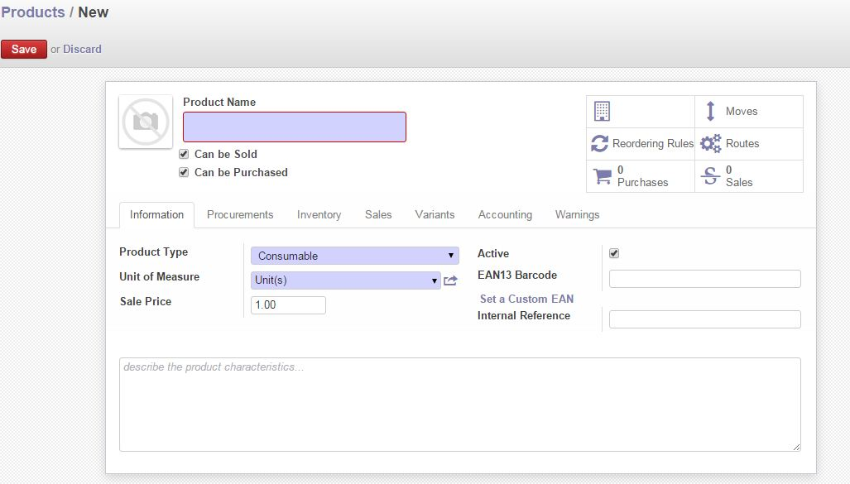

Fig: Product Basic Tab

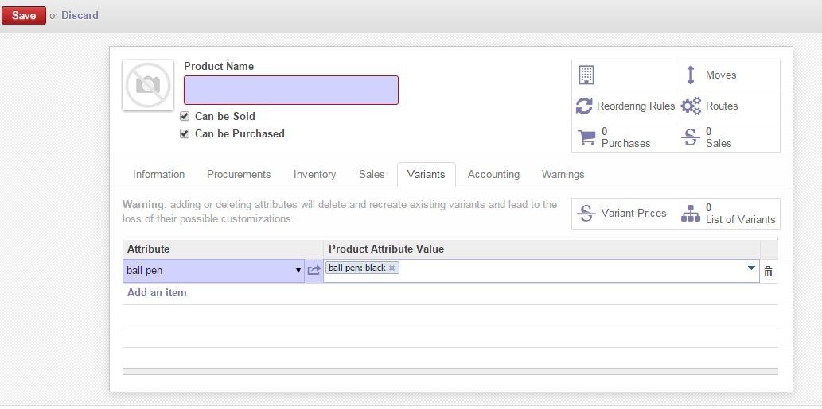

Fig: Product Variant Tab

## Indent

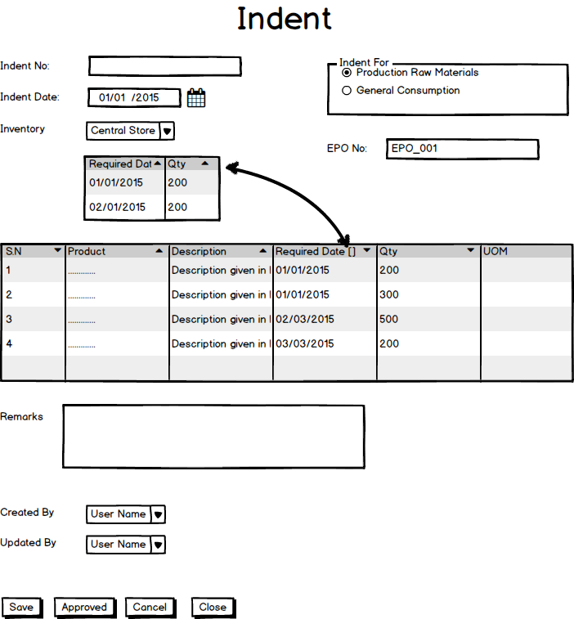

Fig: Indent

## Inventory Receive

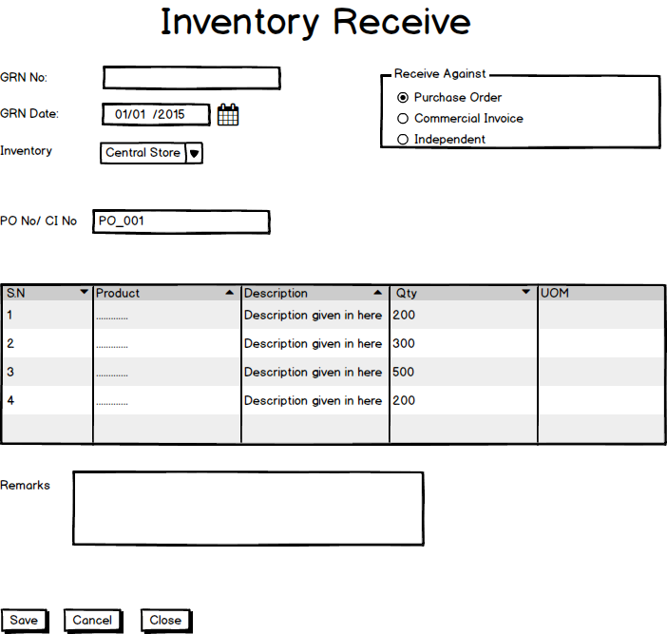

Fig: Inventory Receive

## Receive Return

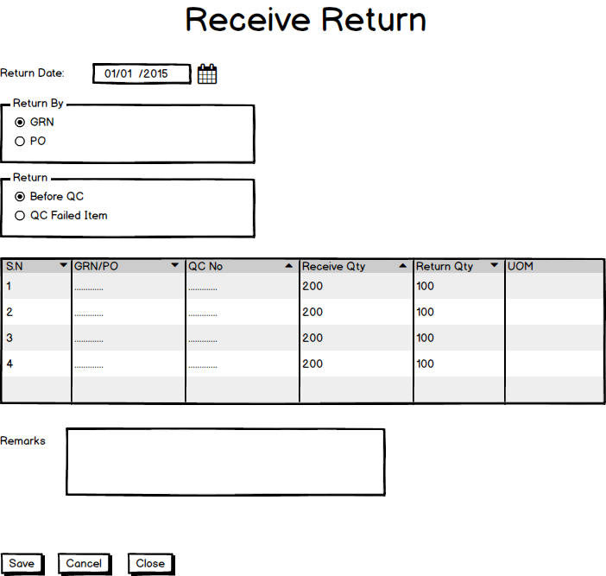

Fig: Receive Return

## Inventory QC

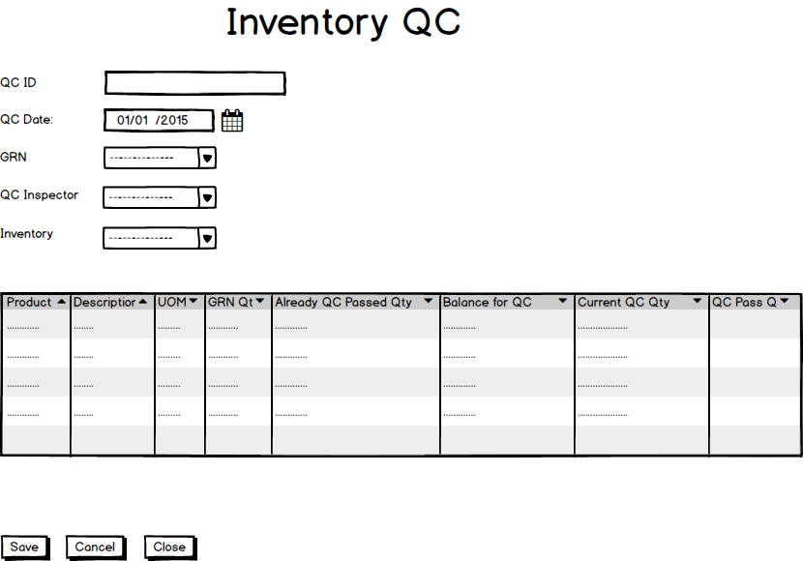

Fig: Inventory QC

## Inventory Transfer Out

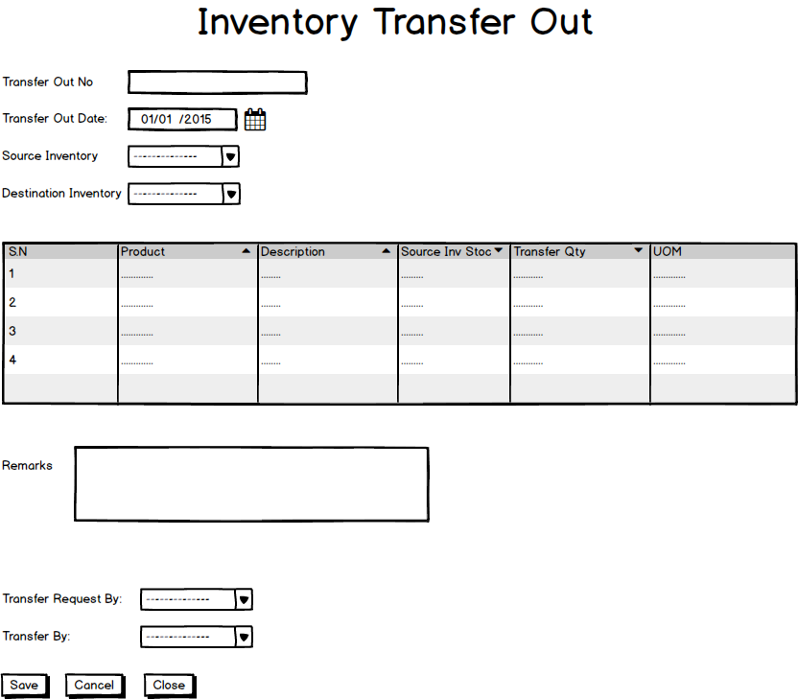

Fig: Inventory Transfer Out

## Inventory Transfer In

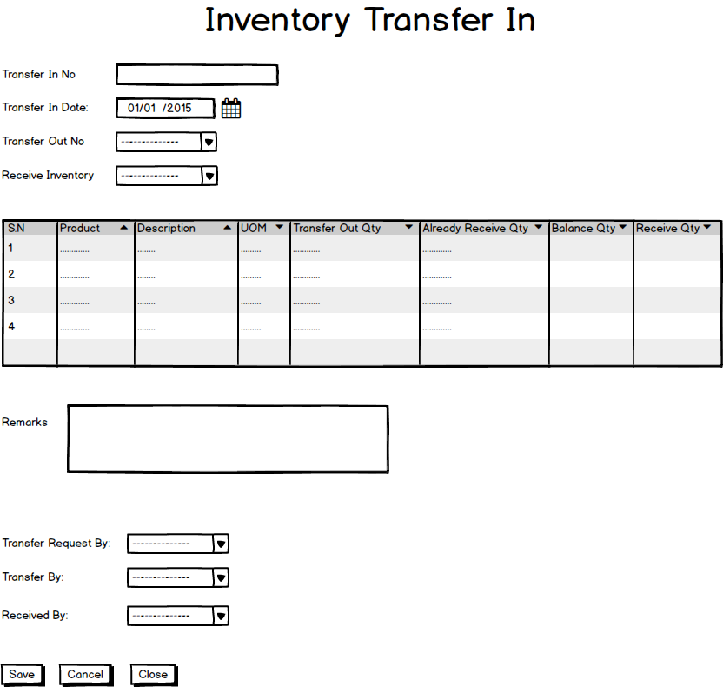

Fig: Inventory Transfer In

## Inventory Item allocation &De-allocation

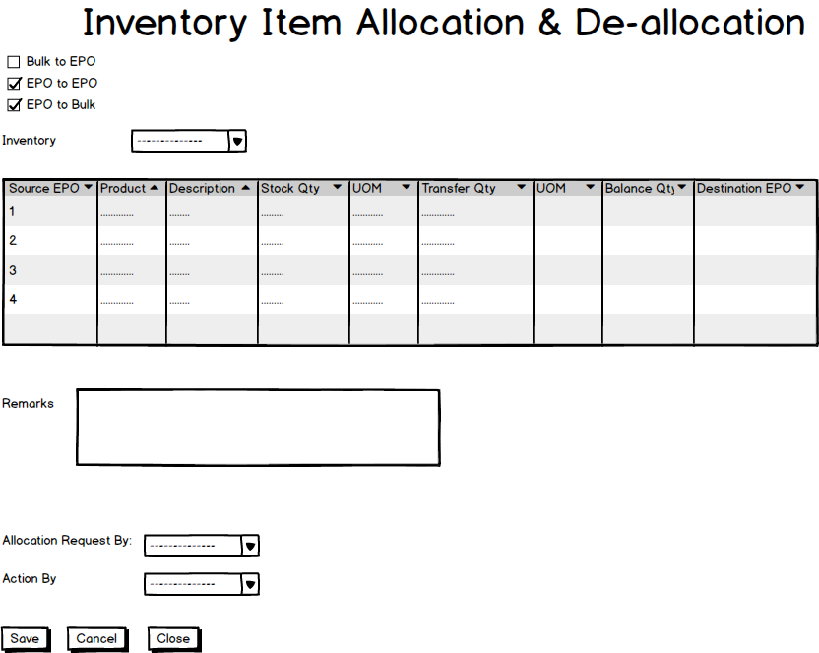

Fig: Inventory Item Allocation & De-Allocation

## Inventory Issue

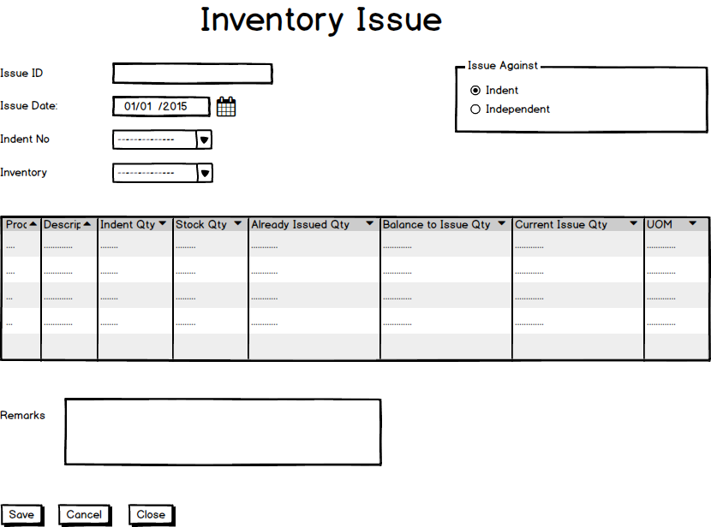

Fig: Inventory Issue

## Physical Inventory

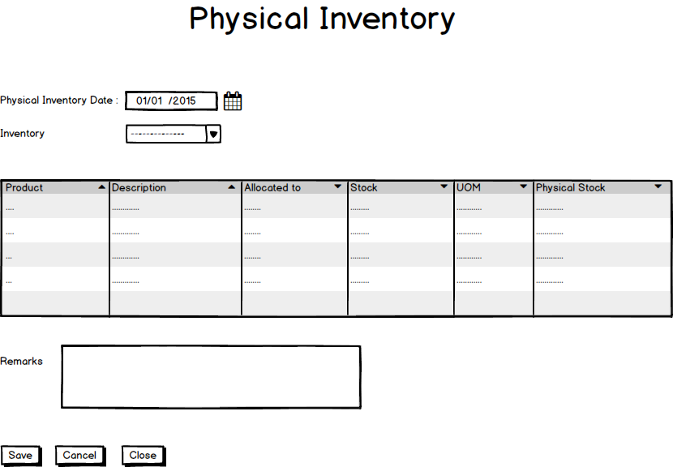

Fig: Physical Inventory

## Item Adjustment

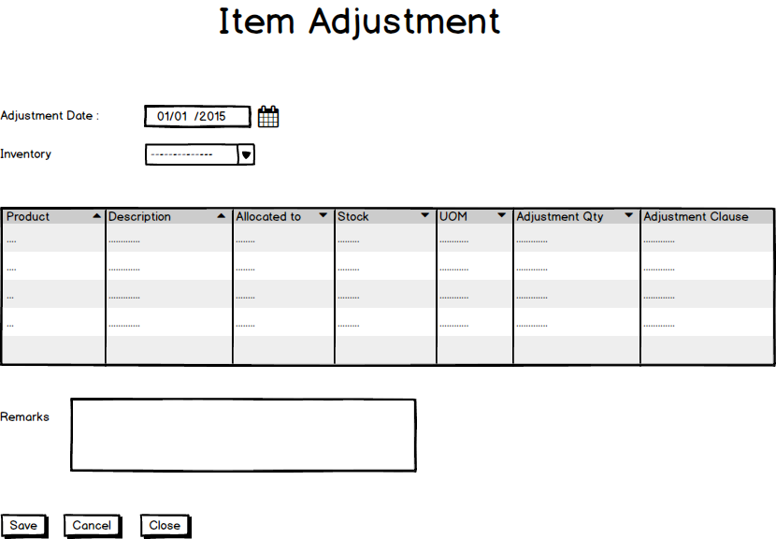

Fig: Item Adjustment